Earning our Recycling Badge
[Skip's Note: Two of our Troop recently completed all of their requirements for the Recycling challenge award. Here, in their own words, is an overview of what they chose to do and where they found the resources. We hope that some of you will find this an aid in your own approach to this award.]

From: Bronson and Adrian
To: Skip
Subject: Recycling Badge
Date: Saturday, March 20, 1999 10:15 AM
For our recycling badge we did the following:
1) We visited the National Film Board Web Site at www.nfb.ca
2) At the site we searched for movies on the environment and recycling. We found a few and took note of their numbers and titles.
3) We called the NFB (phone # 514-496-6887, Listed in the blue pages for the Government of Canada) and found out that we could rent movies if we had a membership card and you need a drivers license to get a card.
4) We went to the NFB Video Club at 1564 St. Denis in Montreal. Several of the movies we had picked were not available in Montreal and some were available to be viewed only at the NFB. They have several computers to search for information, and viewing screens, and special programs available at their office.
5) Movies cost $3.00 each for the first night and $1.00 for each additional night if you let them know in advance. If you return a movie late, it is $3.00 extra each night.
6) Their hours are from Tuesday to Sunday from noon until 9:00 PM. There is a mail slot to return movies when they are closed.
7) We looked up additional information for our presentation on the Internet at www.compost.org for info on composting.
8) For Aluminum recycling we went to www.alcan.com
9) We also went to www.recycle.net but a lot of the information there is complicated and meant for people in the recycling business.
10) Other sites visited were www.cfis.com.au/recycling.html (about steel can recycling) www.glassworks.org/glassworks.html and the Recycling Council of Ontario at www.rco.on.ca
All of this provided us with plenty of information for a recycling discussion and presentation to our troop.
For part 3 of the badge we helped organize and run a waste reduction and recycling program for our cub and scout winter camp.
For this we:
1) tried to buy groceries with little or no packaging (bulk foods were good) and we made sure the packaging was recyclable.
2) At the camp we removed the regular garbage cans and had one can for recyclables, one can for compostables, and one can for non-recyclables.
3) At the end of the weekend camp of about 30 people we had almost no garbage that was not recycled or composted. The garbage we had that had to be dumped with regular trash filled less than a quarter of a paper shopping bag.
Adrian & Bronson
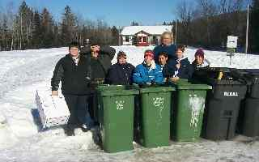
Here are we all - the "Recyclers"- at the Winter Camp '99

Keeping Warm at -20 Celcius
That building you see in the background in our "family picture" is of course only for emergencies... Our preferred accommodations are "the great outdoors".
Our individual "bedroll" designs vary, according to budget and beliefs. Skip recommends a layered sleeping ensemble, as seen here:
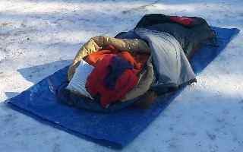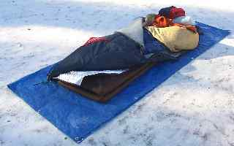
The lowest layer is a tarp, to help protect Arundel's closed-cell foam matresses - two or more thereof. The mattresses are probably the single most important element; lifting the bed off the frozen ground and insulating the sleeper. Never try to sleep directly on the ground, or worse on an air mattress - it pulls the heat from your body, right through the bag.
On the mattresses (& below the bag itself) is a silvered bedroll, to help reflect more body heat back to me.
Some of us own or borrow arctic sleeping bags. They are heavy, bulky and expensive, though, and unless you camp often in the winter, probably not an affordable option for most. My main bag is rated for only -8C, so I have added a couple of enhancements to get me down to -20C; an internal fleece liner (which adds approximately 5 degrees to a bag's rating), and the whole assembly stuffed into a normal (10C) summer sleeping bag. (I don't know what the final rating would be, but I was literally "warm as toast" when I slept overnight at -20C). To hedge my bets, the zippers for the 3 nested bags are on alternate sides - definitely a challenge to "coccoon" into at night, but less likely to produce a cold stripe up the sleeper's back, if wind should find its way into the shelter... NOTE: That fleece liner was a $50 (Cdn) investment, and I had to think hard before I spent it, but boy am I happy now! Worth every penny. Pull that drawstring around the shoulders & no more cold wind "wuffing" around my shoulders, as I roll around in the bag - Yes I have a mummy bag, but I still found it chilly, BF (before fleece).
The bright red thing is a folded fleece jacket - much warmer than a damp pillow on the face at night. The pillow underneath it, though, is more comfortable than just the fleece.
"Capping-off" the ensemble, note the thermal underwear balaclava (learned the hard way not to pull the head inside the bag to stay warm - soaking wet in the morning, just from breath condensation - now wear a hood over a balaclava, to keep the old noggin warm, despite much tossing and turning in my sleep. (Found that without the hood, the back of the balaclava would "ride up" and I got a cold neck that often woke me up. The balaclava keeps the face & nose warm.

Experimenting with Winter Shelters
We had some bad luck with snow conditions, last year, with the ice storm and warm weather. The quinzhee did not work out too well for us. This year, we decided to experiment with three other styles of shelter
Two of us hollowed-out a mound of snow, braced it with bamboo poles, filled it with mattresses and covered it with a tarp.
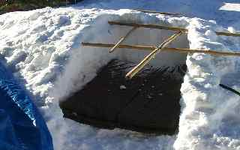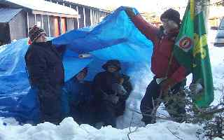
We had planned to cover the tarp with snow, too, but in the end it was not necessary. (NOTE: The axe was only used to help hollow-out the mound of packed snow & ice. We don't think Johnny slept with it).
Four of us tried sleeping in summer-weight (3-season) tents, with no attempt to further insulate them.
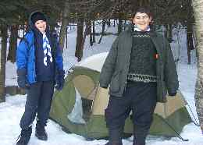
We were pitched in the woods & the wind was mildly gusting. These sleepers were also fine, overnight.
The third group dug a large "pit", built a tall teepee, and draped it over with a huge tarp.
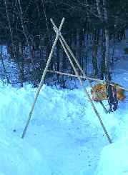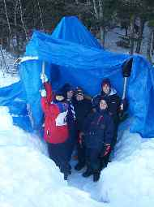
They then filled the pit with tarps and mattresses & slept in a group (sort of an "artificial cave"). One Scout ended up spending the full night OK - one woke up half out of his bag & was too chilled to stay out at that point. (Good call! Nice to know smarts still rule over bravado.)
Overall - from a comfort point of view, we found that any of the 3 options worked just fine. The tent was clearly the least amount of effort & the teepee looked like it could have become a problem if the wind had picked-up (if only because the noise of the tarp whipping in the wind would keep you and your neighbours awake).

